# Practical No. 01

**Aim: A) Program to calculate a number of samples required for the image. Code:**

clc; close; m=4; n=6; N=400; N2=2*N;

Fs=m*N2*n*N2;

disp('Number of samples required to preserve the informationin the image = ',Fs);

**Output:**

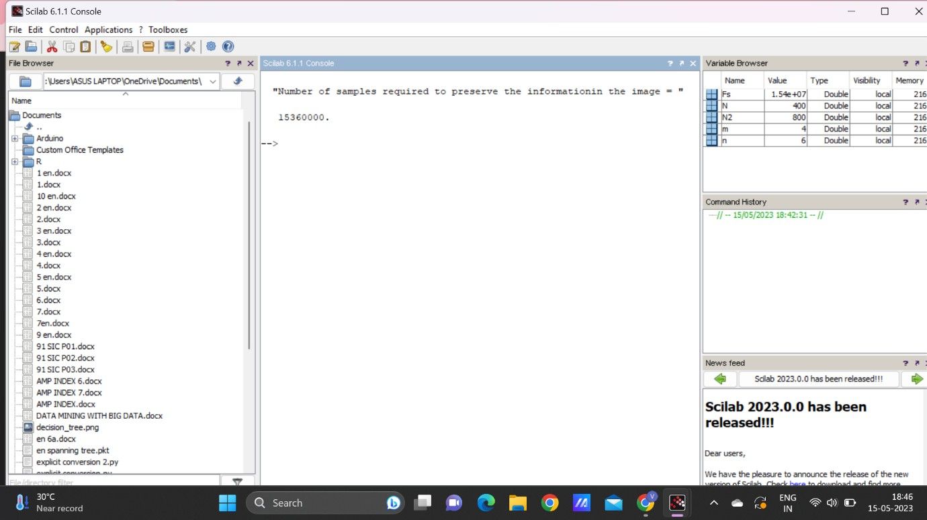

**Aim: B) Program to study the effects of reducing the spatial resolution of a digital image.**

**Code:**

n = input('Enter the input samples'); img=rgb2gray(imread('D:\damon.jpeg')); a=size(img);

w=a(2);

h=a(1);

im=zeros(100); for i=1:n:h

for j=1:n:w for k=0:n-1 for l=0:n-1

im(i+k,j+l)=img(i,j); end

end end end

subplot(1,2,1); imshow(uint8(img));title('Original image'); subplot(1,2,2); imshow(uint8(im));title('sampled image');

**Output:**

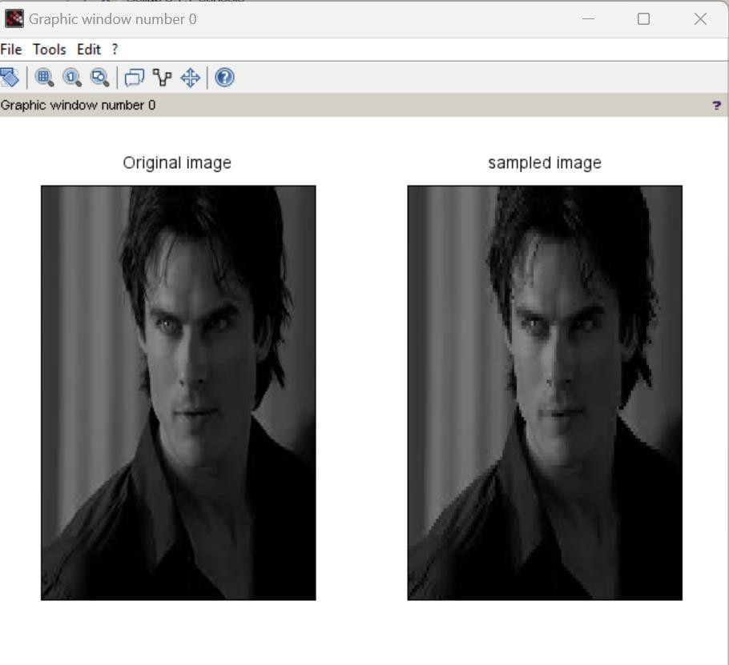

# Practical No. 02

**Aim: WAP to study the effect of reducing the quantization values and spatial resolution.**

1. **Quantization Code:**

a=imread('D:\damon.jpeg'); [m,n]=size(a);

for i=1:m for j=1:n

b(i,j)=(a(i,j))/255*63;

c(i,j)=(a(i,j))/255*127;

d(i,j)=(a(i,j))/255*191; end

end subplot(2,2,1),imshow(a),title('Original');

subplot(2,2,2),imshow(b),title('Quantized 63');

subplot(2,2,3),imshow(c),title('Quantized 127');

subplot(2,2,4),imshow(d),title('Quantized 191');

**Output:**

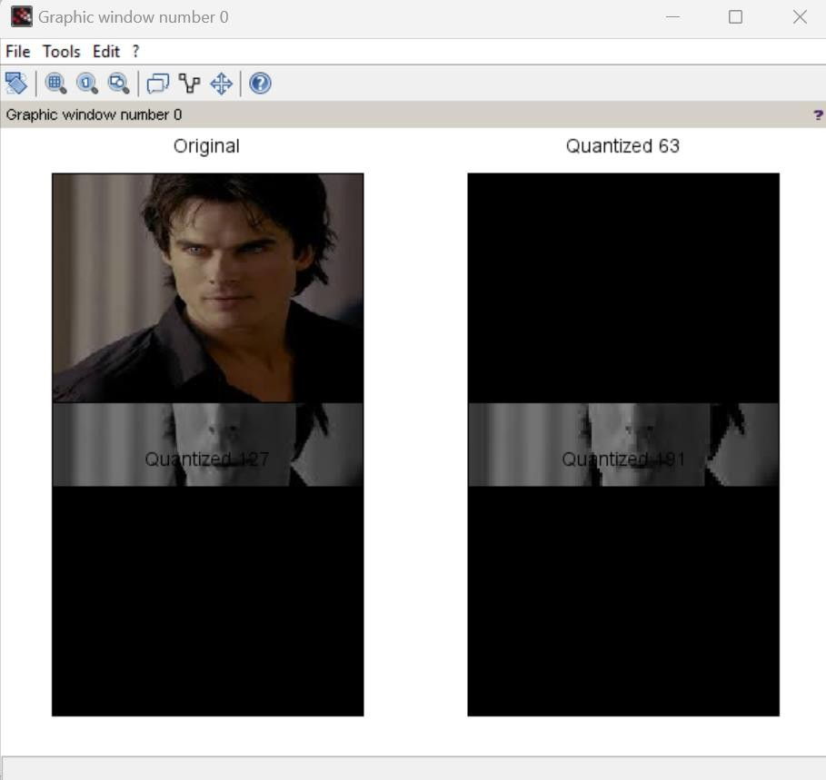

1. **Spatial Resolution Code**: i=imread('D:\damon.jpeg'); a=imresize(i,0.8); b=imresize(i,0.6); c=imresize(i,0.4);

subplot(2,2,1),imshow(i),title('Original');

subplot(2,2,2),imshow(a),title('0.8');

subplot(2,2,3),imshow(c),title('0.6');

subplot(2,2,4),imshow(c),title('0.4');

**Output:**

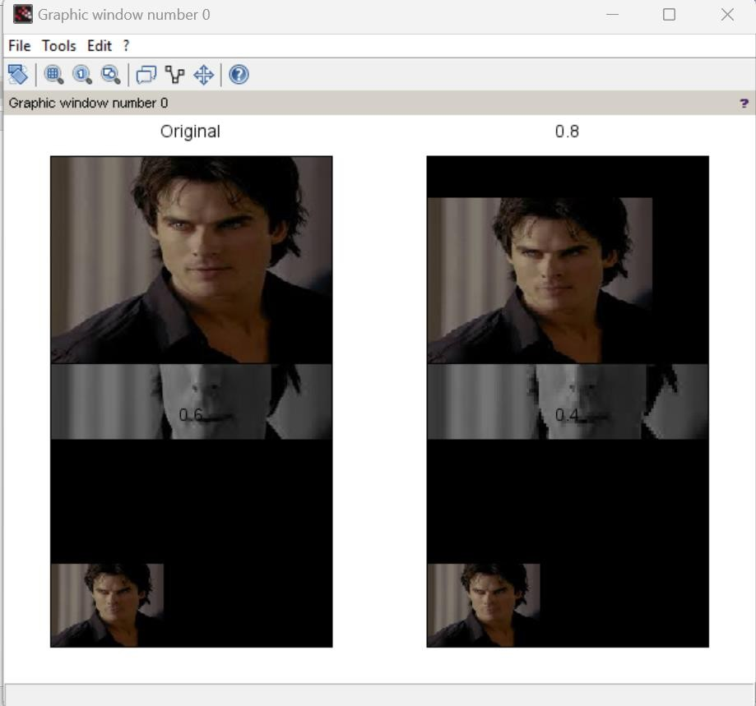

# Practical No. 03

**Aim: Image Enhancement**

1. **Thresholding code:**

a=imread('D:\damon.jpeg'); [m,n]=size(a);

for i=1:m for j=1:n x=a(i,j);

if x >= 128 b(i,j)=a(i,j)+70;

c(i,j)=a(i,j)+80;

d(i,j)=a(i,j)+100; else

b(i,j)=a(i,j)-70;

c(i,j)=a(i,j)-80;

d(i,j)=a(i,j)-100; end

end end

subplot(2,2,1),imshow(a),title('Original'); subplot(2,2,2),imshow(b),title('Threshold Vlaue : 70'); subplot(2,2,3),imshow(c),title('Threshold Vlaue : 80'); subplot(2,2,4),imshow(d),title('Threshold Vlaue : 100');

**Output:**

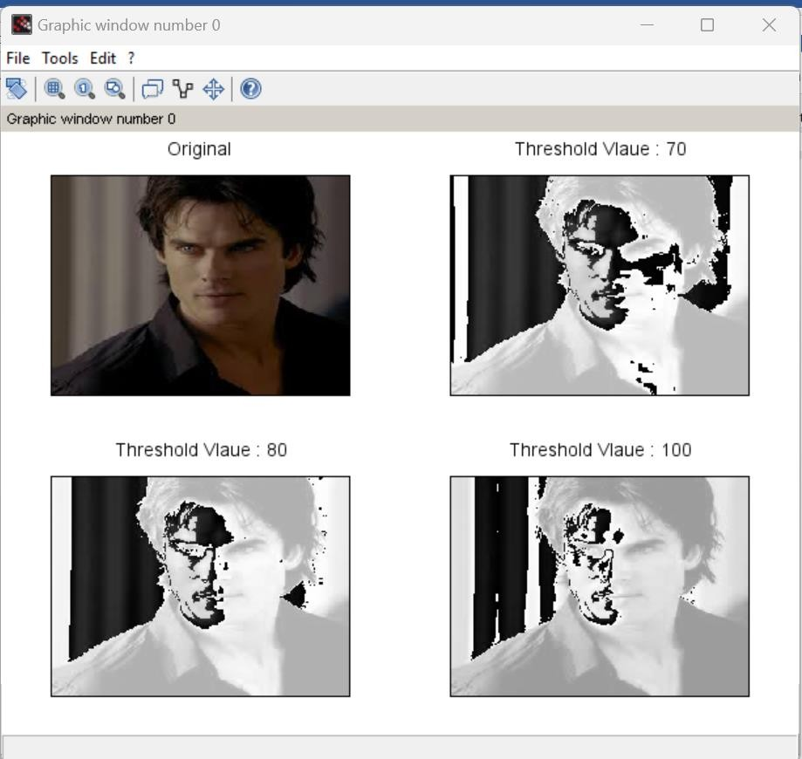

1. **Contrast Adjustment:**

**Code:** a=imread('D:\damon.jpeg'); r1=100;

r2=140; s1=150; s2=240;

l=s1/r1;

m=(s2-s1)/(r2-r1);

n=(255-s2)/(255-r2);

s=size(a); for i=1:s(1) for j=1:s(2)

if ((a(i,j) > 0) && (a(i,j) < r1)) b(i,j) = a(i,j)*l;

end

if ((a(i,j) > r1) && (a(i,j) < r2))

b(i,j) = (m*(a(i,j)-120))+s1; end

if ((a(i,j) > r2) && (a(i,j) < 256))

b(i,j) = (n*(a(i,j)-150))+s2; end

end end

subplot(1,2,1),imshow(a),title('Original Image'); subplot(1,2,2),imshow(uint8(b)),title('Contrast Image');

**Output:**

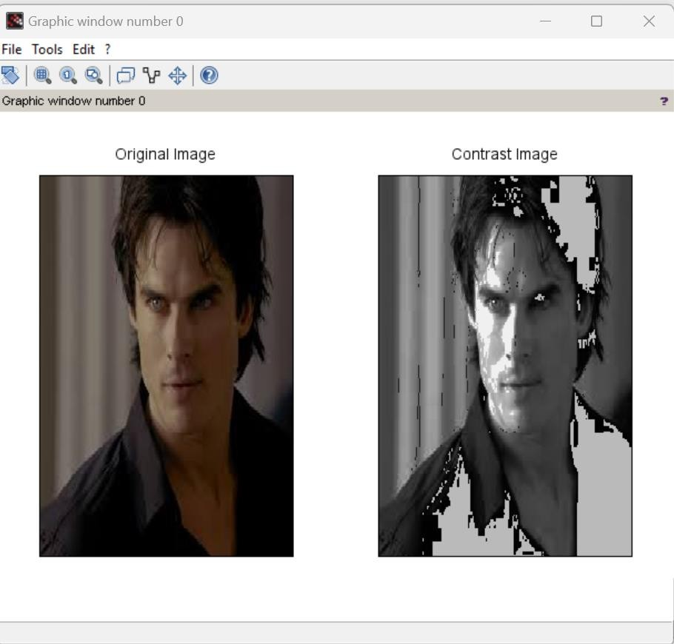

1. **Brightness Adjustment:**

**Code:** a=imread('D:\damon.jpeg'); [m,n]=size(a);

for i=1:m for j=1:n

b(i,j)=a(i,j)-50;

c(i,j)=a(i,j)-100;

d(i,j)=a(i,j)+50; end

end subplot(2,2,1),imshow(a),title('Original');

subplot(2,2,2),imshow(b),title('Reduced By 50');

subplot(2,2,3),imshow(c),title('Reduced By 100');

subplot(2,2,4),imshow(d),title('Increase By 50');

**Output:**

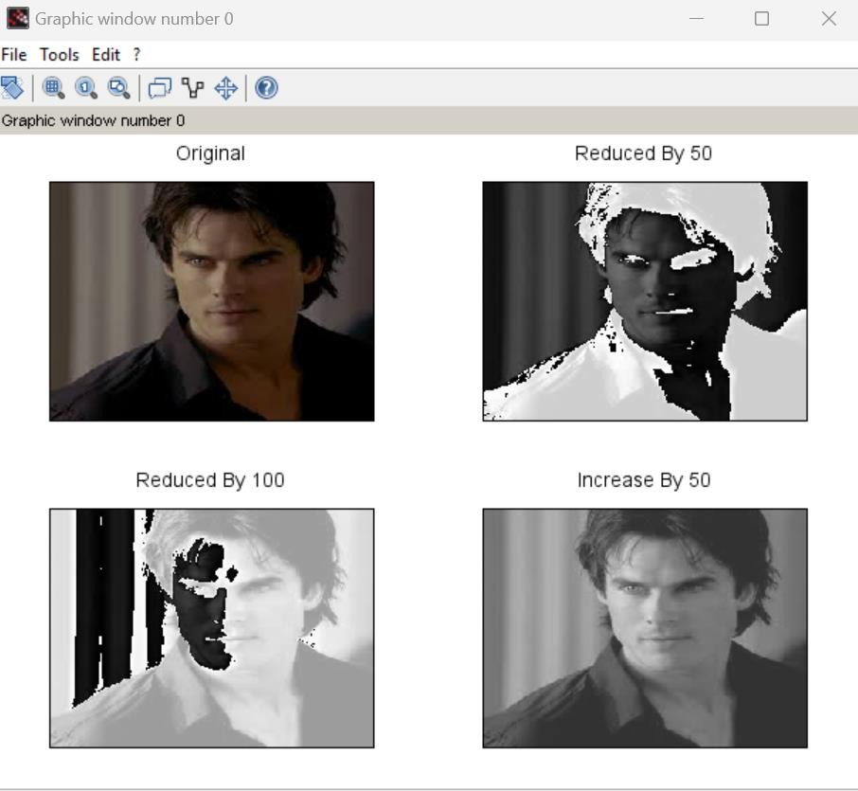

1. **Gray Level Slicing:**

**code:** a=imread('D:\damon.jpeg'); [m,n]=size(a);

min = 100;

max= 200; for i=1:m for j=1:n x=a(i,j);

if x > min && x < max b(i,j)=a(i,j);

elseif x > max b(i,j)=255;

else b(i,j)=0; end

end end

subplot(1,2,1),imshow(a),title('Original'); subplot(1,2,2),imshow(b),title('Gray Slicing');

**Output:**

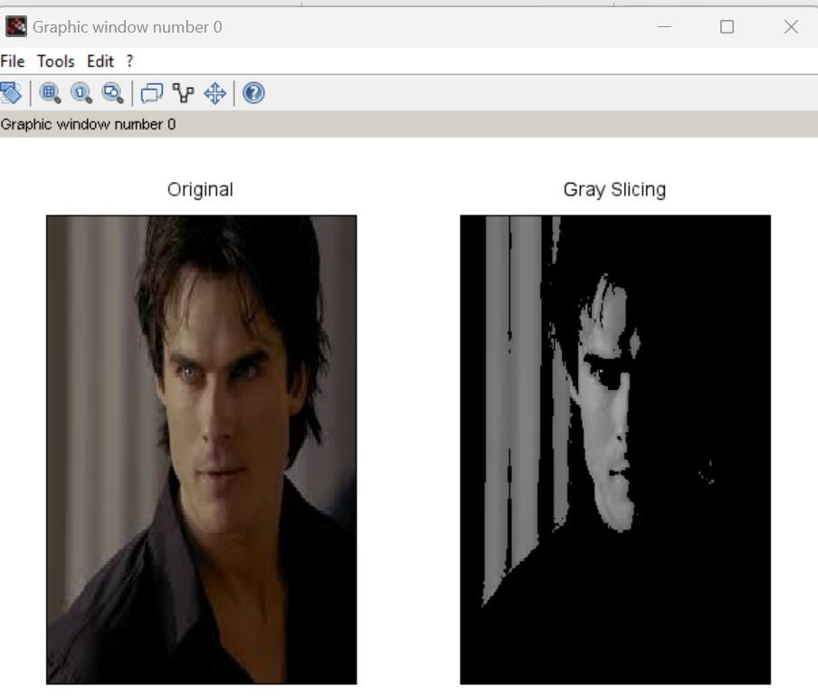

# Practical No. 04

**Aim: Basic Transformation**

1. **Log Transformation:**

**Code**: a=imread('D:\klaroline.jpeg'); [m,n]=size(a);

for i=1:m for j=1:n x=a(i,j);

b(i,j)=20*log(1+double(x)); end

end subplot(1,2,1),imshow(a),title('Original');

subplot(1,2,2),imshow(b),title('Log Transform');

**Output:**

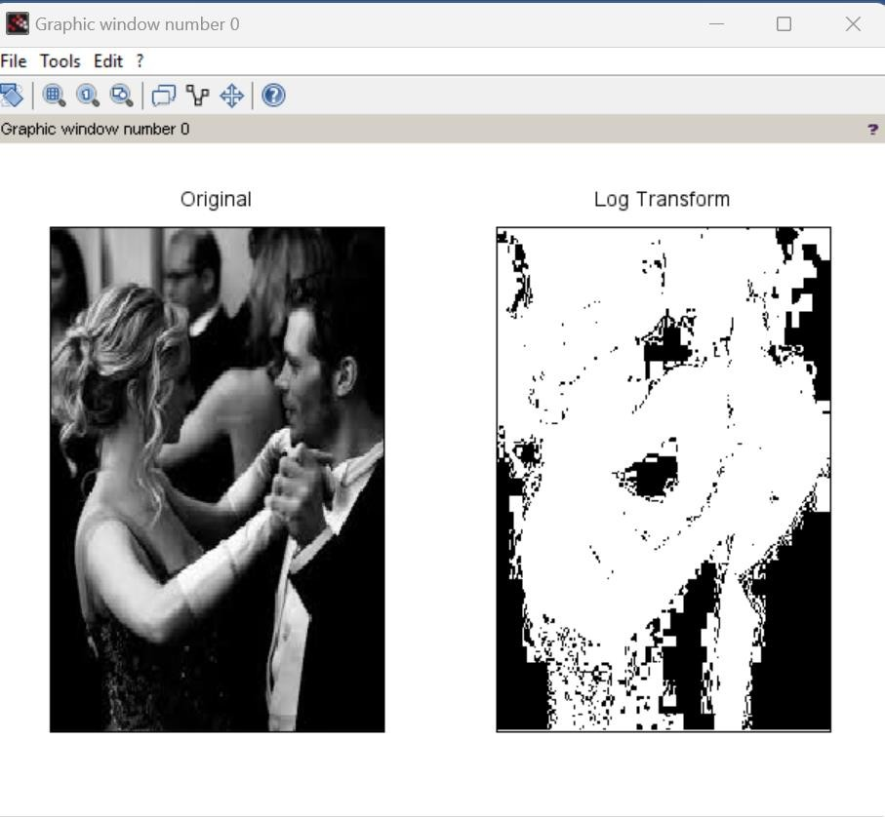

1. **Power Law Transformation:**

**code:**

a=imread('D:\cameraman.jpeg'); [m,n]=size(a);

for i=1:m for j=1:n

x=double(a(i,j));

b(i,j)=20*(x^0.4);

c(i,j)=20*(x^0.6);

d(i,j)=20*(x^0.9); end

end subplot(2,2,1),imshow(a),title('Original');

subplot(2,2,2),imshow(b),title('Power Law Transform : Gamma = 0.4'); subplot(2,2,3),imshow(c),title('Power Law Transform : Gamma = 0.6'); subplot(2,2,4),imshow(d),title('Power Law Transform : Gamma = 0.9');

**Output:**

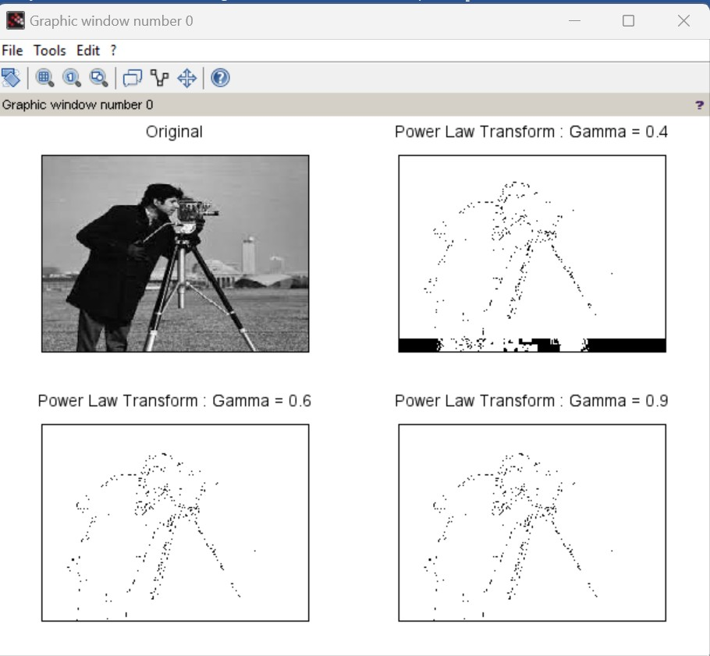

1. **Negation code code:**

a=imread('D:\klaroline.jpeg'); [m,n]=size(a);

for i=1:m for j=1:n

b(i,j)=255 - a(i,j); end

end subplot(1,2,1),imshow(a),title('Original');

subplot(1,2,2),imshow(b),title('Negation');

**Output:**

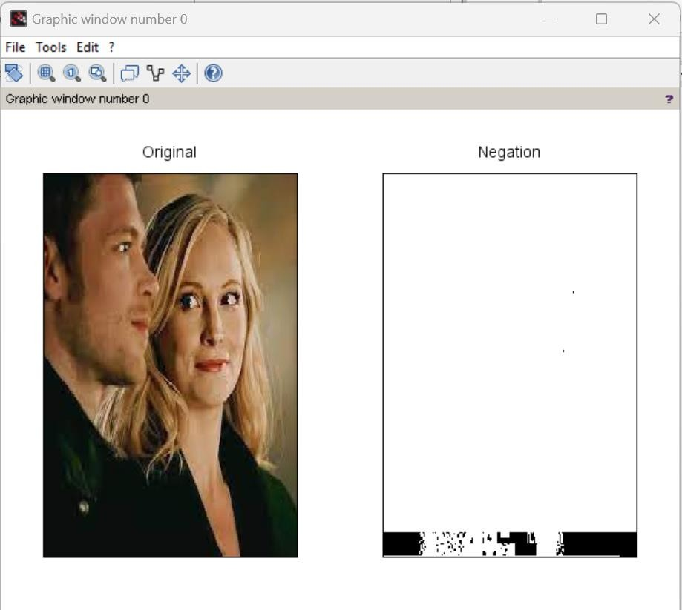

1. **Piecewise linear transformations code:**

clc; clear all;

a=imread('D:\klaroline.jpeg'); b=double(a);

subplot(2,3,1); imshow(a); title('Original Image'); f1=bitget(b,1); subplot(2,3,2); imshow(f1);

title('bit 1 Image'); f2=bitget(b,2); subplot(2,3,3); imshow(f2); title('bit 2 Image'); f3=bitget(b,4); subplot(2,3,4); imshow(f3); title('bit 3 Image'); f4=bitget(b,6); subplot(2,3,5); imshow(f4); title('bit 6 Image'); f5=bitget(b,8); subplot(2,3,6); imshow(f5); title('bit 8 Image');

**Output:**

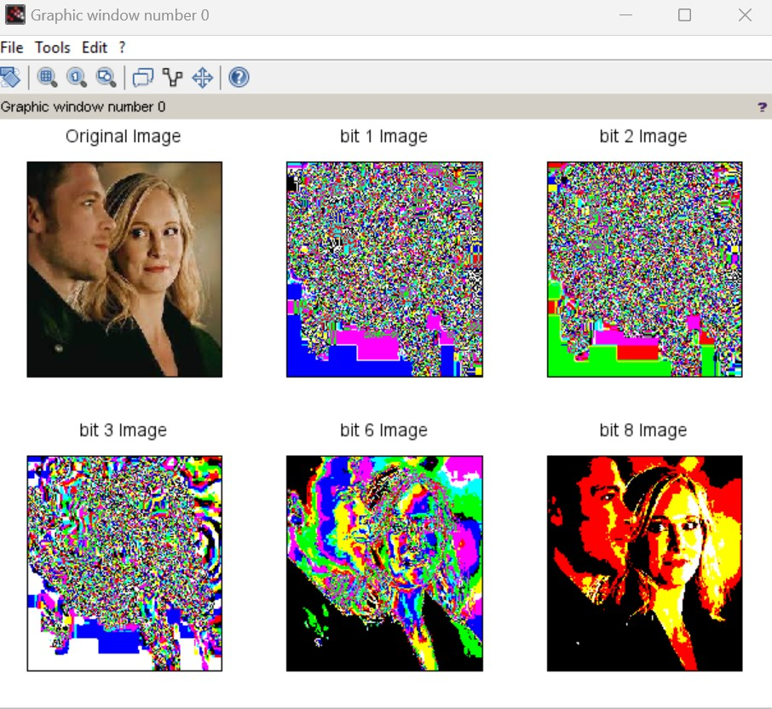

# Practical No. 05

**Aim: A) Write a program to plot a Histogram for Colour and Grayscale Images. Code:**

a = imread('D:\klaroline.jpeg'); a = double(a);

[row col] = size(a); h = zeros(1,300); for n = 1:1:row

for m = 1:1:col if a(n,m) == 0 a(n,m) = 1; end

end end

for n = 1:1:row for m = 1:1:col t = a(n,m);

h(t) = h(t)+1; end

end

subplot(1,2,1),imshow(uint8(a)); title('Original Image'); subplot(1,2,2),bar(h),title('Histogram');

**Output:**

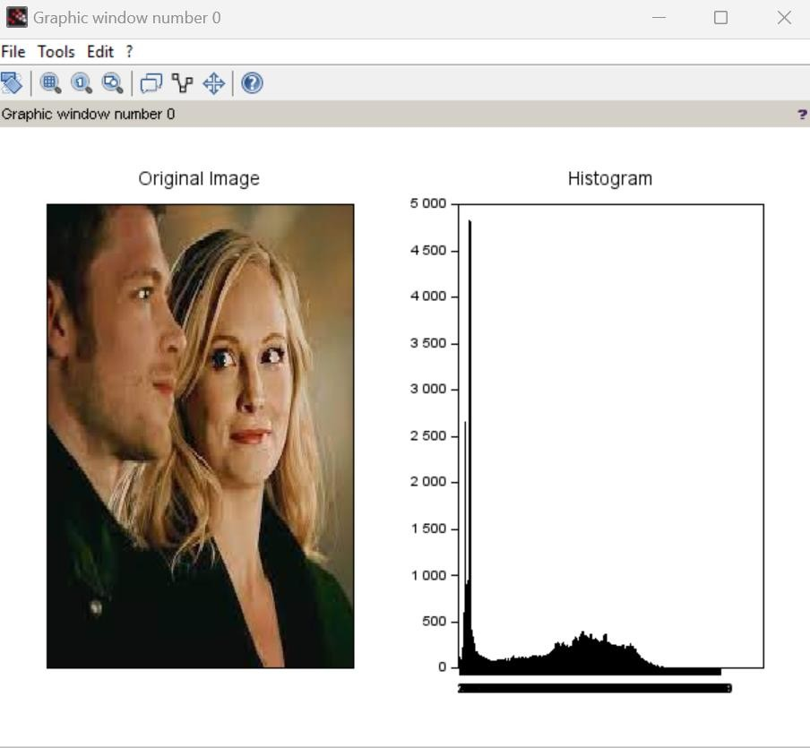

1. **Write a program to apply histogram equalization. Code:**

a = imread('D:\klaroline.jpeg'); a = double(a);

big = 256;

[row col d] = size(a); c = row*col;

h = zeros(1,300); z = zeros(1,300); for e = 1:1:d

for n = 1:1:row for m = 1:1:col if a(n,m,e) == 0

a(n,m,e) = 1; end

end end end

for n = 1:1:row for m = 1:1:col t = a(n,m);

h(t) = h(t)+1; end

end

pdf = h/c; cdf(1) = pdf(1); for x = 2:1:big

cdf(x) = pdf(x) + cdf(x-1); end

new = round (cdf*big); new = new + 1;

for r = 1:1:d for p = 1:1:row for q = 1:1:col

temp = a(p,q,r);

b(p,q,r) = new(temp);

t = b(p,q,r);

z(t) = z(t) + 1; end

end end

b = b-1;

subplot(2,2,1); imshow(uint8(a)); title('Image');

subplot(2,2,2); bar(h); title('hist');

subplot(2,2,3); imshow(uint8(b)); title('After hist Image'); subplot(2,2,4); bar(z); title('Eq Hist');

**Output:**

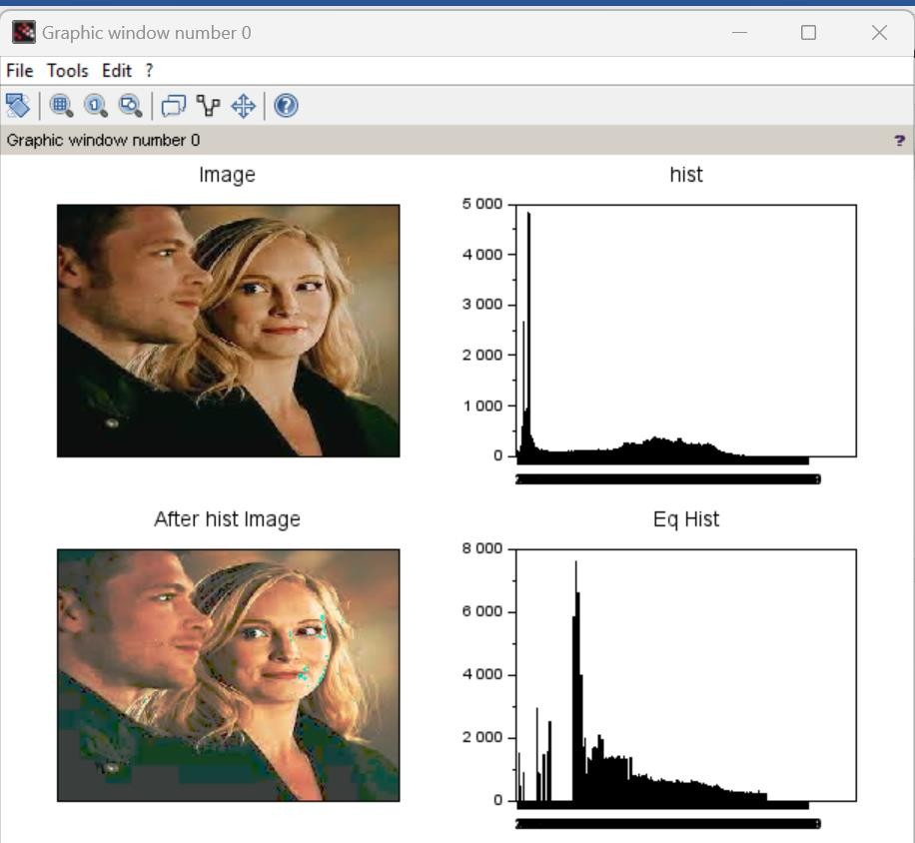

# Practical No. 06

**Aim: Write a program to apply Gaussian filter on an image. Code:**

m=input('Enter the Size '); s=input('Enter the value of sigma '); sum1=0;

a=m/2; p=0;q=0; r=1;

t=1;

w=floor(a); for i=-w:w for j=-w:w p=i*i; q=j*j;

g(r,t)=exp(-(p+q)/(2*s*s)); sum1=sum(sum(g(r,t)+sum1)); t=t+1;

end t=1;

r=r+1; end

for r=1:m for t=1:m

h(r,t)=g(r,t)/sum1; t=t+1;

end t=1;

r=r+1; end

im=imread('D:\cameraman.jpeg'); p=double(im);

s1=0;

[M N]=size(p); for x=0:M-m for y=0:N-m for s=1:m

for z=1:m s1=(h(s,z)*(p(x+s,y+z)))+s1; end

end N_img(x+1,y+1)=s1; s1=0;

end end

subplot(1,2,1),imshow(uint8(im)),title('Original Image'); subplot(1,2,2),imshow(uint8(N_img)),title('Image After Gaussian Filter');

**Output:**

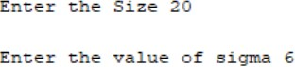

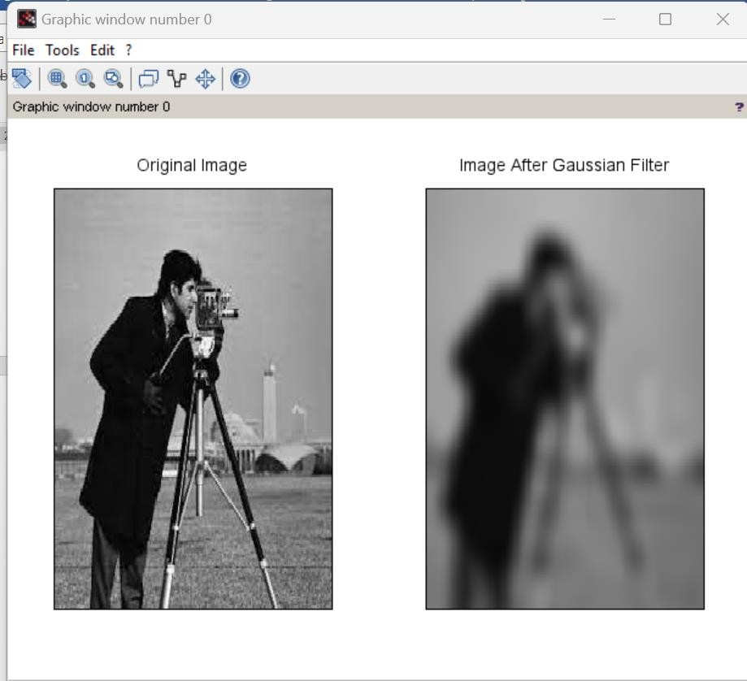

# Practical No. 07

**Aim: 1) Write a program to apply following morphological operations on the image**.

* 1. **Opening Code :** img=imread('cameraman.tif'); se1 = strel('square',11);

im2 = imerode(img,se1); im3 = imdilate(im2,se1);

subplot(1,2,1),imshow(img),title('orignal image'); subplot(1,2,2),imshow(im3),title('opening image');

**Output:**

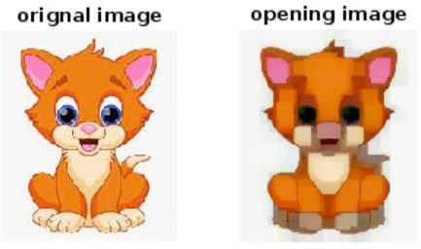

* 1. **Closing Code :**

aa=imread('cameraman.tif'); se1=strel('square',11); IM2=imdilate(aa,se1); IM3=imerode(IM2,se1);

subplot(1,2,1),imshow(aa),title('Original Image'); subplot(1,2,2),imshow(IM3),title('Closed Image');

**Output:**

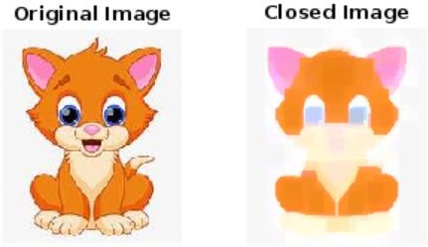

* 1. **Morphological Gradient Code :** img=imread('cameraman.tif'); se1=strel('square',12); im1=imdilate(img,se1); im2=imerode(im1,se1); g=im1-im2;

subplot(2,2,1),imshow(img),title('Orignal Image'); subplot(2,2,2),imshow(im1),title('Dilation Image'); subplot(2,2,3),imshow(im2),title('Erotion Image'); subplot(2,2,4),imshow(g),title('Gradient Image');

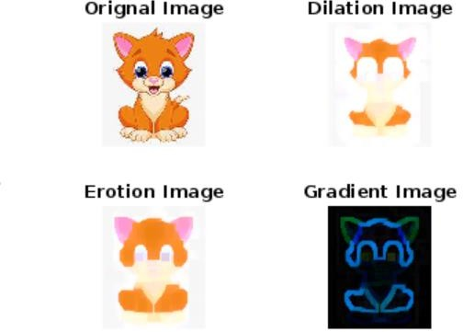**Output:**

* 1. **Top-hat transformation Code:**

i=imread('cameraman.tif'); se1=strel('square',22); im1=imerode(i,se1); im2=imdilate(im1,se1); h=i-im2;

subplot(2,2,1),imshow(i),title('Orignal Image'); subplot(2,2,2),imshow(im1),title('Erotion Image'); subplot(2,2,3),imshow(im2),title('Dilation Image'); subplot(2,2,4),imshow(h),title('Top Hat Transformation Image');

**Output:**

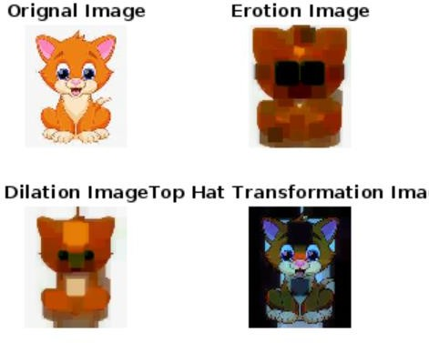

**Aim: 2) Write a program for boundary detection. Code:**

clear all; clc;

aa=imread('moon.jpeg'); se1=strel('square',11); subplot(2,1,1),imshow(aa); m1=imerode(aa,se1); m2=aa-m1;

title('orignal image'); subplot(2,1,2),imshow(m2); title('edge detection');

**Output:**

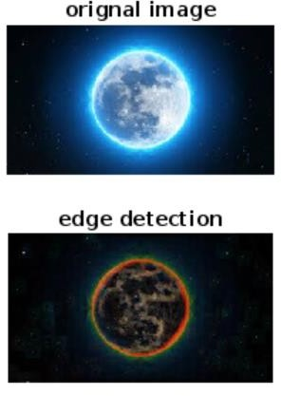

# Practical No. 08

**Aim: A) Write a program to show RGB planes Code:**

original=imread('D:\klaroline.jpeg'); im_red=original(:,:,1); im_green=original(:,:,1); im_blue=original(:,:,3);

subplot(2,2,1),imshow(original),title('Original'); subplot(2,2,2),imshow(im_red),title('Red'); subplot(2,2,3),imshow(im_green),title('Green'); subplot(2,2,4),imshow(im_blue),title('Blue');

**Output:**

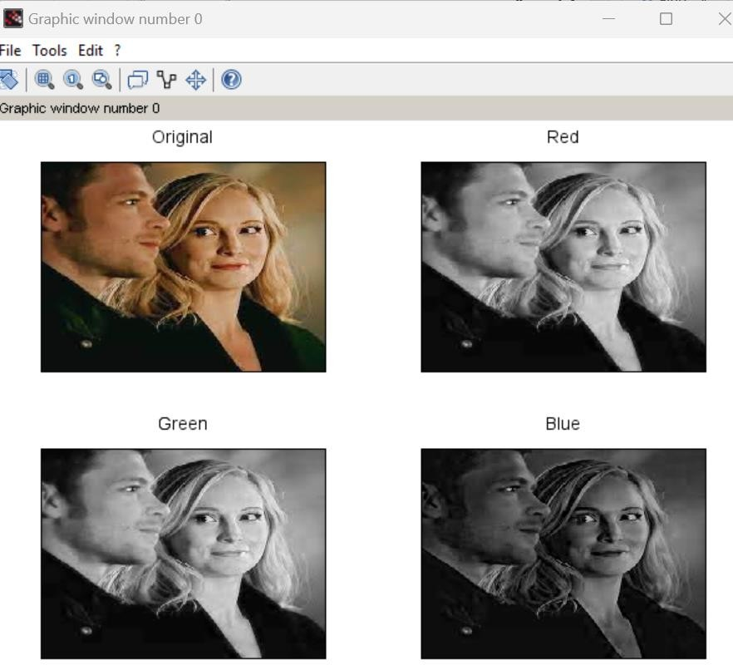

**Aim: B) WAP to convert RGB to NTSC**

**RGB to YCbCr RGB to CMY**

**Code:**

clc; clear all; close all;

a = imread('D:\lotus.jpeg'); figure(1),imshow(a); title('Orignal Image'); k=rgb2ntsc(a); figure(2),imshow(k); title('RGB TO NTSC');

l=rgb2ycbcr(a); figure(3),imshow(l); title('RGB TO YCbCr'); m=imcomplement(a); figure(4),imshow(m); title('RGB TO CMY');

imr=a(:,:,1);

img=a(:,:,2);

imb=a(:,:,3); figure(5),imshow(imr); figure(6),imshow(img); figure(7),imshow(imb); I=(imr+img+imb)/3; [m,n]=size(imr);

for c=1:m for d=1:n

min1=min(imr(c,d),img(c,d)); min2=min(min1,imb(c,d));

S(c,d) = 1-(3/(imr(c,d)+img(c,d)+imb(c,d)))*min2; end

end

for c=1:m for d=1:n

temp= (0.5*(imr(c,d)-img(c,d))+(imr(c,d)- imb(c,d)))/sqrt(double(imr(c,d)*imr(c,d)+(imr(c,d)-imb(c,d))*(img(c,d)-imb(c,d)))); H(c,d)=acos(double(temp));

end end

for c=1:m for d=1:n

finali(c,d,1)=I(c,d);

finali(c,d,2)=S(c,d);

finali(c,d,3)=H(c,d); end

end

figure(8),imshow(finali); title('Final image');

**Output:**

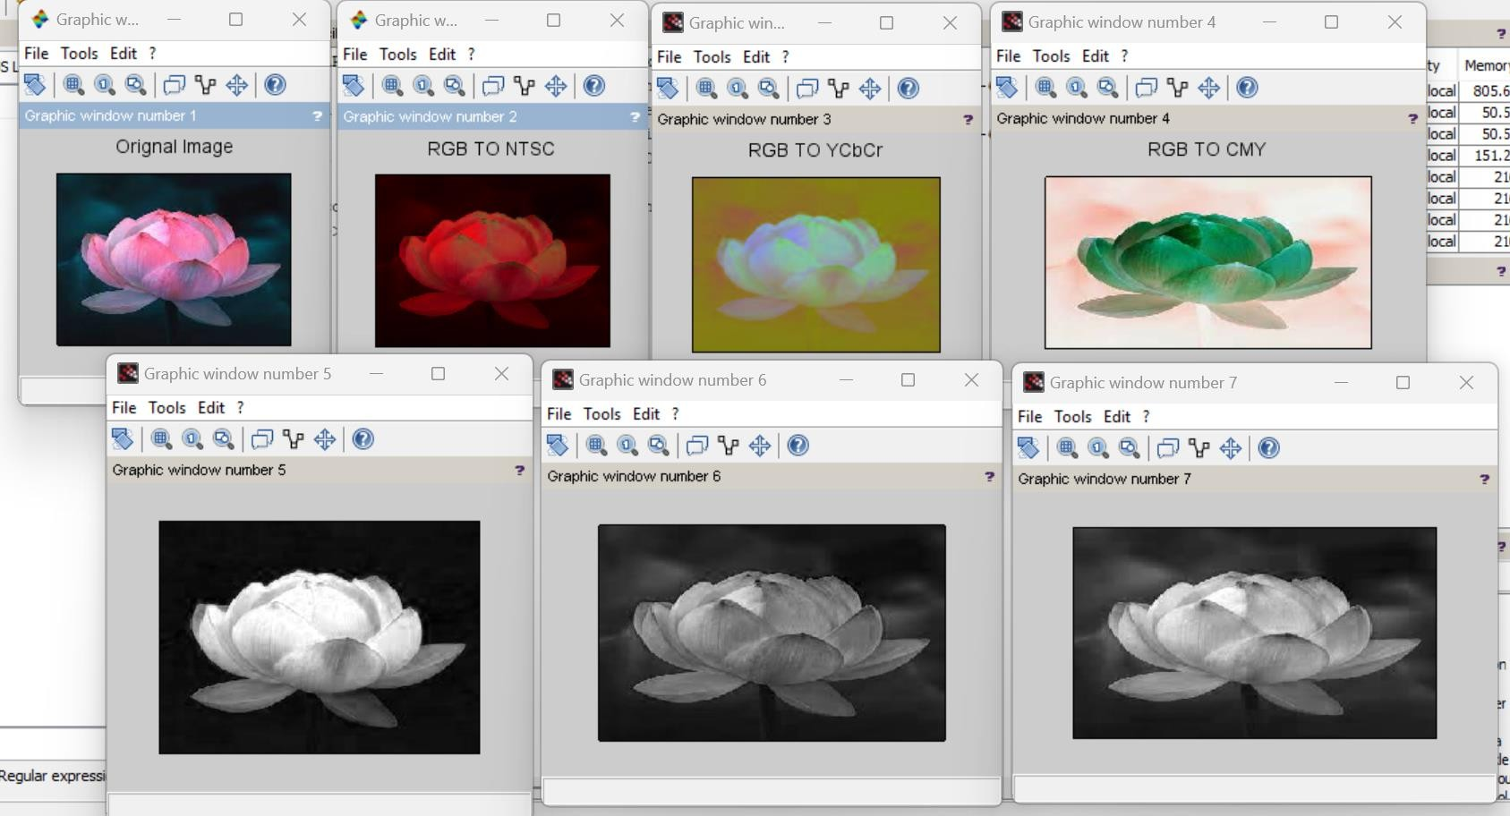

# Practical No. 09

**Aim: Write a program to achieve Pseudo coloring. Code:**

a=imread('D:\lotus.jpeg'); [l,m,n]=size(a);

for i=1:l for j=1:m for k=1:n

if a(i,j)>=0 & a(i,j) < 50 b(i,j,1)=a(i,j,1)+50;

b(i,j,2)=a(i,j,1)+100;

b(i,j,3)=a(i,j,1)+10;

end

if a(i,j)>=50 & a(i,j) < 100 b(i,j,1)=a(i,j,1)+35;

b(i,j,2)=a(i,j,1)+128;

b(i,j,3)=a(i,j,1)+10;

end

if a(i,j)>=100 & a(i,j) < 150 b(i,j,1)=a(i,j,1)+152;

b(i,j,2)=a(i,j,1)+130;

b(i,j,3)=a(i,j,1)+15;

end

if a(i,j)>=150 & a(i,j) < 200 b(i,j,1)=a(i,j,1)+50;

b(i,j,2)=a(i,j,1)+140;

b(i,j,3)=a(i,j,1)+25;

end

if a(i,j)>=200 & a(i,j) < 256 b(i,j,1)=a(i,j,1)+120;

b(i,j,2)=a(i,j,1)+160;

b(i,j,3)=a(i,j,1)+45;

end end end end

subplot(1,2,1),imshow(a),title('Original'); subplot(1,2,2),imshow(b),title('Pseudo Image');

**Output:**

